Our program accepts two additional parameters through the MPICH2 CLI/CMD line.

Those parameters are:

int size = atoi(argv[1]);

int bucketsSize = atoi(argv[2]);

size - is the number of elements in the original array to be distributed among the two computers.

bucketsSize – is the interval value.

In class exercises it was the range [0,255] i.e. bucketsSize=256.

The program supports -for the examiner convenience- DEBUG mode.

There are two DEBUG modes, when they are activated (not omitted in the program.cpp) according to the users input for the additional params the program has different outcomes that mitigate the program check i.e. debug.

When size <=50, the program will print the original array of data after instantiation.

When size>=100000 and bucketsSize=2,

The data array is being instantiated with only two 1 so one 1 is in one half and the other is in the other half.

The output will always show final result and runtime.

Any other values beside those mentioned above will make the data array to be randomly instantiated.

Examples:

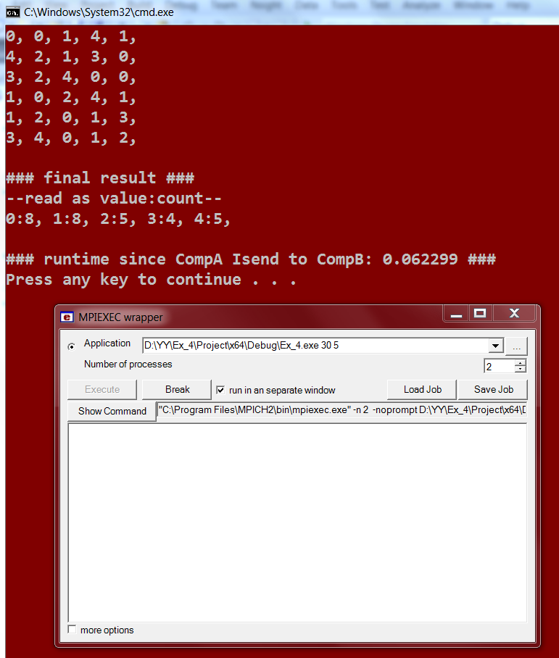

**bucketsSize**

**size**

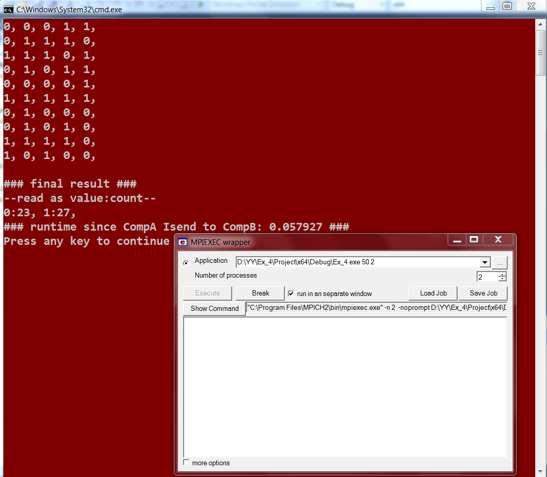

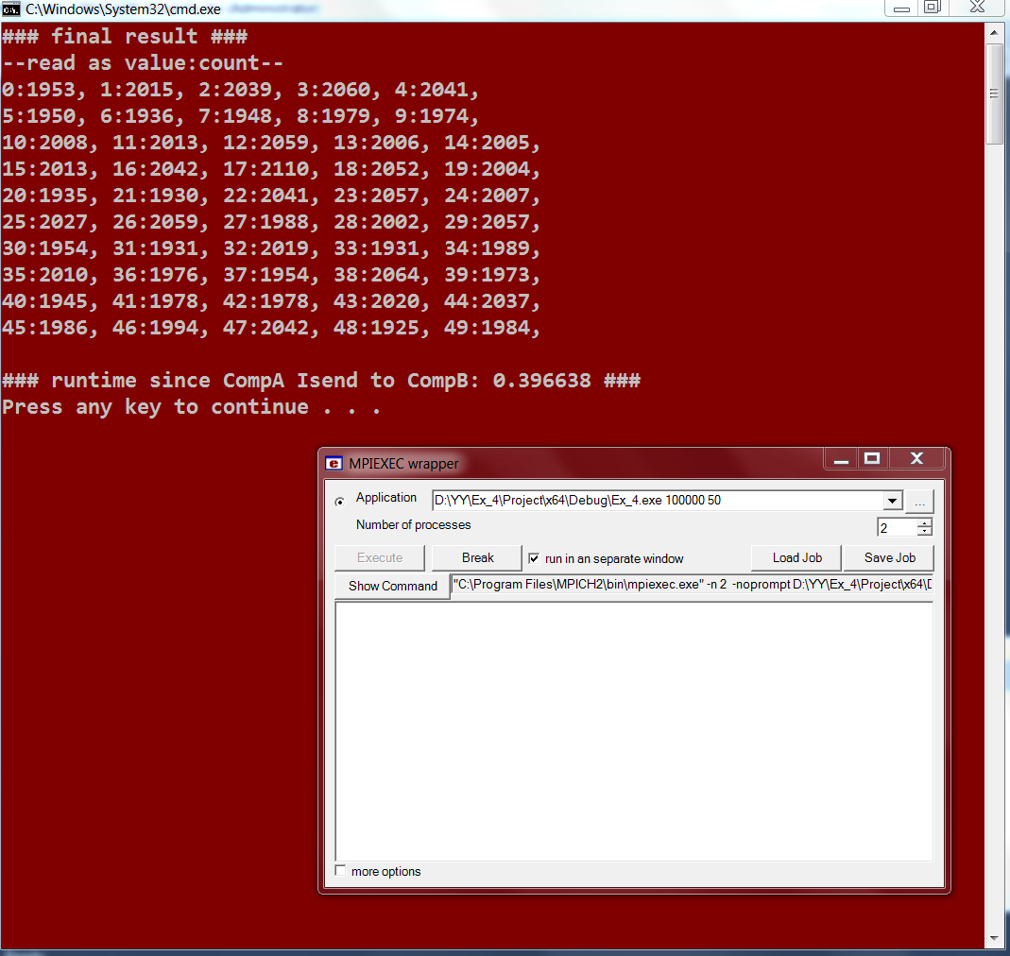

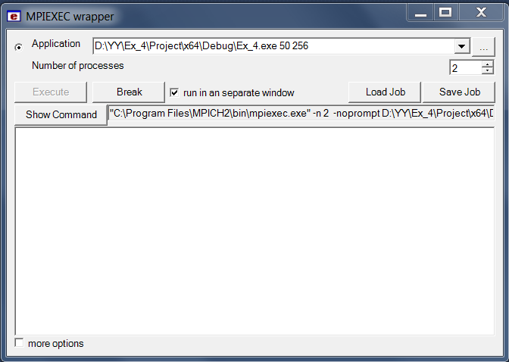

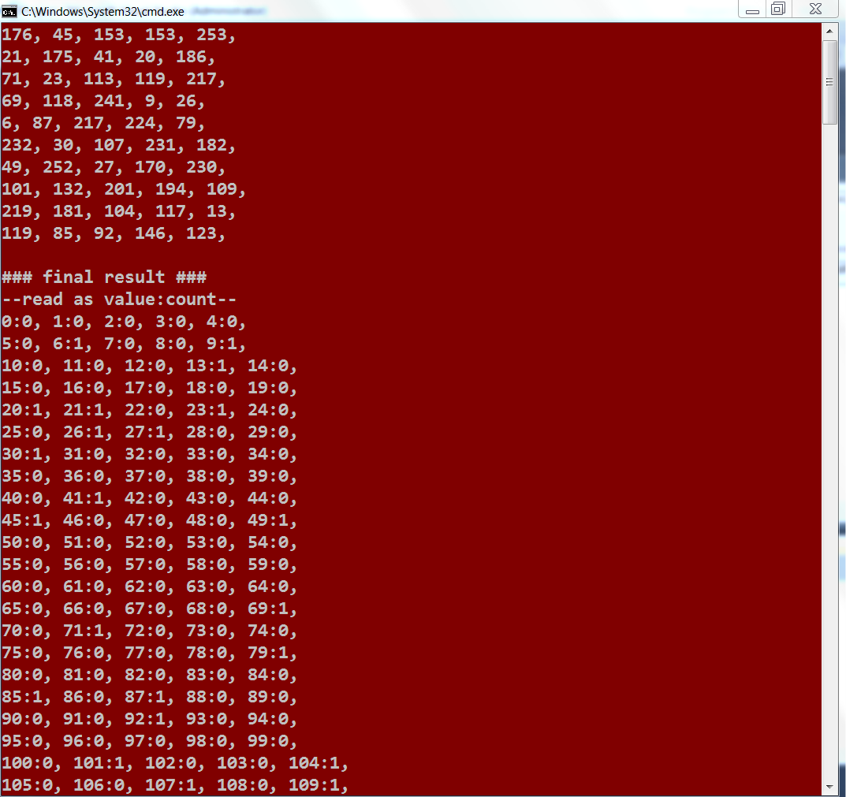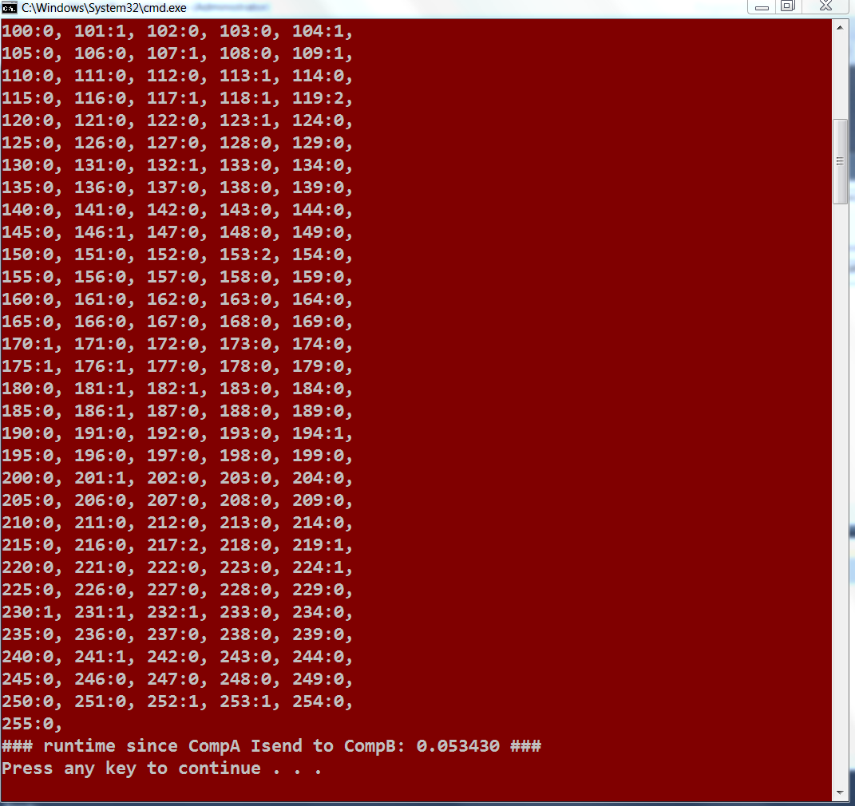

Should be used with the word magnifier below to the right…

